**Documentation for Major Project**

**Step 1:** Have anaconda installed and have visual studio code installed.

The Data Extraction and Rule based engine is in the Mp.ipynb which must be opened via jupyter notebook from anaconda.

**Step 2:** Download all the files and place them in the major_project folder and extract the resume and the skills folder in the major_project folder.

**Step 3:** Create a Folder in documents called “major_project” and place the Mp.ipynb and constants.py in the same folder.

**Step 4:** In the anaconda prompt to the following steps in order.

pip install pymupdf

pip install spacy

python -m spacy download en

pip install pymysql

**Step 5:** Then uncomment all the nltk.download and run the cell

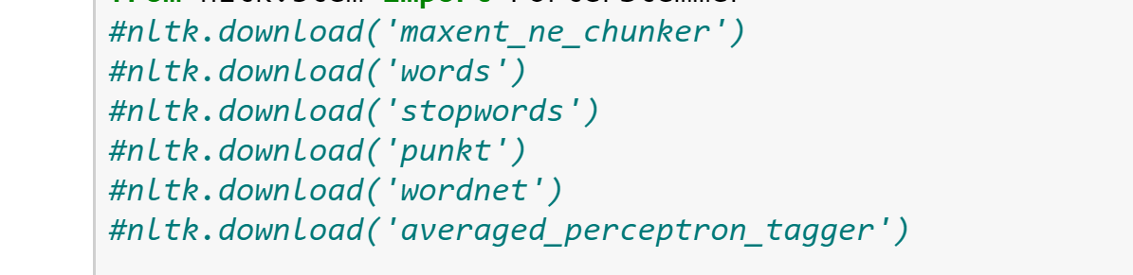

**Step 6:** After downloading you can comment it back

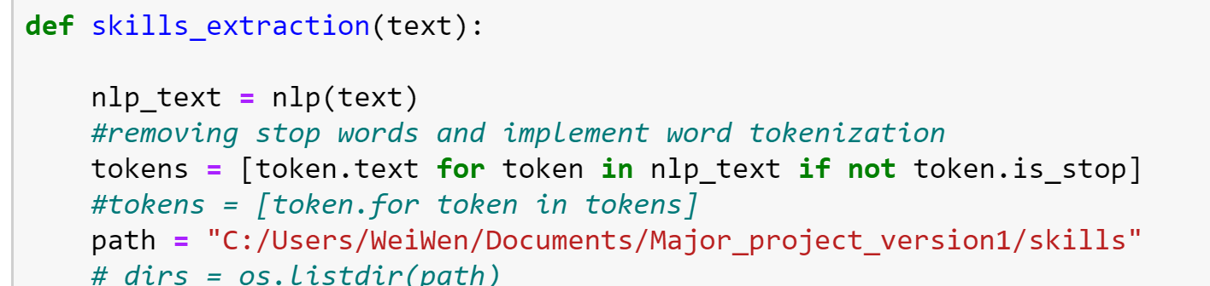

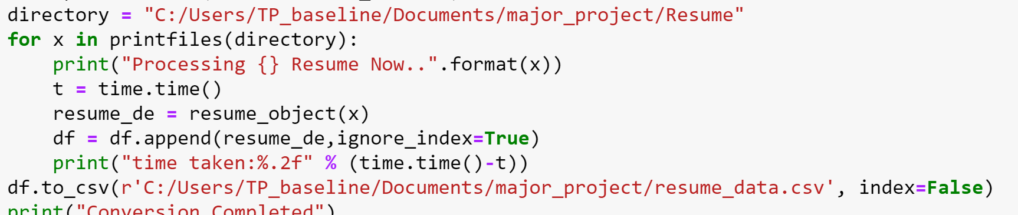

**Step 7:** Change the path to where the skills and resume file is in the major_project/skills and major_project/Resume.

**Step 8:** And Change the path for the resume_data.csv in the same folder.

**Step 9:** Download Xamp and change the ini.file for mysql into a different port for all port change the port number from 3306 to 3304 and start the server.

**Step 10:** Then download mysql workbench and run a mp.sql script in mysql.

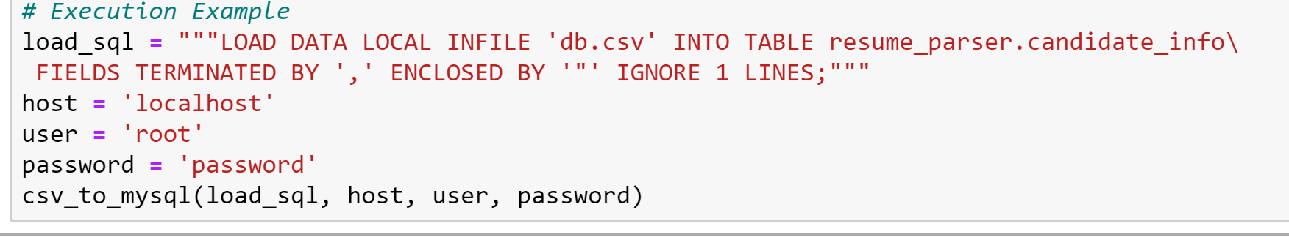

**Step 11:** Change the db information to your mysql credentials

**Step 12:** Go into mysql workbench and run the following codes:

“””

SHOW GLOBAL VARIABLES LIKE 'local_infile';

SET GLOBAL local_infile = 'ON';

SHOW GLOBAL VARIABLES LIKE 'local_infile';

“”’

**Step 13:** Then go back to mp.ipynb and go to the kernel and click restart and run all

After running the database should have 5 records of the resumes and you would have a final.csv file with all the information.

UI Setup

**Step 14:** Download the mp_updated_ui and place it in the major_project folder and unzip it.

**Step 15:** Download visual studio code and open the mp_updated_ui as a folder.

Go to the server.js file and find :

const connection = mysql.createPool({

host: 'localhost',

user: 'root',

password: 'password',

database: 'resume_parser'

});

Replace with your credential for mysql

**Step 16:** Now Press Ctrl and ~ at the same time to open command prompt and run “npm install” and wait for it to install.(Ensure you have wifi signal)

**Step 17:** Then run “npm run dev”

**Step 18:** Then once it is compiled successfully go to chrome and enter “ localhost:8080/home ”

After that then click on the AIDA logo to view the candidates table

This icon is to view the information of the candidate

**Step 19:** Go to job roles and click dashboard for data engineer to view the data engineer dashboard and **Step 20:** click the overall dashboard to see the overall information and finally if there are any errors just re enter localhost:8080/home into the chrome browser.

For more information contact Wei Wen at tanweiwen32@gmail.com